Internal Medicine Department
Rheumatology Workshop
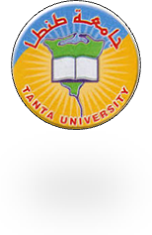
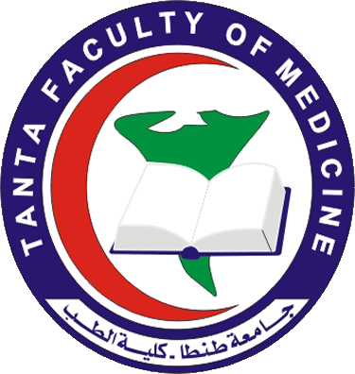
Updates in vasculitis
Venue: Tanta University Teaching Hospital
Date: 2 March 2016
Registration: 9:00-10:00
Session 1: 10:00 – 12:00
Chairpersons: Prof. Mousa Al_Naggar Prof. Ali Yossef,
Prof. Manal Elmenawy
Updates in pathogenesis, diagnosis and classification of vasculitis
10:00 – 11:00 Prof .Manal Elmenawy.
Case presentation 11:00-11:15 (Dr. Rasha Abdelnoor )
Case presentation 11:15-11:30 (Dr. sherin Elnabawy ).
Case presentation 11:30-11:45 (Dr. Haidy Ali ) Discussion 11:45 – 12:00
Break: 12:00-12:30
Session 2 : 12:30 – 02:30
Chairpersons: Prof. Mabrouk Elsheikh – Prof. Ehab Al-Toraby
Prof. Adel Abdesalam
New guidelines in treatment of vasculitis 12:30 - 01:15
Prof. Abeer shahba
Case presentation 01:30 – 01:45 ( Dr. Omnia Darrag )
Case presentation 01:45-02:00 ( Dr. Thanaa Farag )
Discussion 02:00 - 02:30
Closing Remarks & Lunch.

